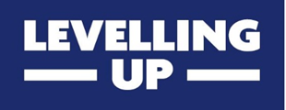

UK Shared Prosperity Fund:
Support for Joint Bids

For a joint bid in South West Wales, it is a requirement that you provide the names of all the applicant organisations that you are jointly working with. Please ensure that the legally registered names are provided.

Joint bids must have the support of all participating organisations. We will check that evidence of support has been provided from all parties. Please confirm if any of your partners are from the non-public sector.

This is an eligibility requirement and if it is not met the bid will not proceed to assessment.

One form should be completed by each of the other organisations participating in the joint bid. Each participating organisation should complete a separate copy, filling in the blank sections, and inserting a signature, The lead applicant must email these with the application, by the submission date to spf@pembrokeshire.gov.uk. This must not be submitted in any other way.

Bid name:
Name of lead applicant organisation:
Name, company/charity registration number and registered address of participating organisation:

By completing and signing this form, I confirm support for this bid, noting any outstanding requirements and/or conditions that need to be met below:

Name: | Job role:
Date: | Signed:

